**A**

**MINI PROJECT REPORT**

**ON**

**TEACHER'S TIMETABLE**

SUBMITTED

BY

**ANAGHA S K**

**(1601-13-737-001)**

**&**

**D.SRIHARIKA**

**(1601-13-737-025)**

FOR THE PARTIAL FULLFILLMENT OF

(2/4)-B.E. INFORMATION TECHNOLOGY

UNDER THE GUIDANCE OF

**Mrs. K.Swathi**

**ASSISTANT PROFESSOR**



DEPARTMENT OF INFORMATION TECHNOLOGY

CHAITANYA BHARATHI INSTITUTE OF TECHNOLOGY

**(Affiliated to Osmania University; Accreditated by NBA (AICTE), ISO Certified 9001:2000)**

**Website:** [**www.cbit.ac.in**](www.cbit.ac.in)**,** [**www.cbitworld.com**](www.cbitworld.com)

HYDERABAD – 500 075

2013-2014

i



**CHAITANYA BHARATHI INSTITUTE OF**

**TECHNOLOGY**

**DEPARTMENT OF INFORMATION TECHNOLOGY**

**(Affiliated to OSMANIA UNIVERSITY)**

**GANDIPET, HYDERABAD-500 075**

**CERTIFICATE**

This is to certify that the project work entitled “**TEACHER'S TIMETABLE**” submitted to **CHAITANYA BHARATHI INSTITUTE OF TECHNOLOGY**, in partial fulfillment of the requirements for the award of the completion of Second year 1st semester of B.E in information technology, during the academic year 2013, is a record of original work done by **ANAGHA S K (160113737001)** and **D.SRIHARIKA(160113737025)** during the period of study in the Dept. of IT, CBIT, HYDERABAD, under our supervision and guidance.

**PROJECT GUIDE**  **HEAD OF THE DEPARTMENT**

**Mrs. K. Swathi Dr. Suresh Pabboju**

Assistant Prof. Dept of IT. **Head of the department**

**Information Technology**

**C.B.I.T., HYDERABAD.**

ii

**ACKNOWLEDGEMENT**

I have taken efforts in this project. However, it would not have been possible without the kind support and help of many individuals and organizations. I would like to extend my sincere thanks to all of them.

I am highly indebted to **Dr. B.Chennakeshava Rao, The Principal**, **C.B.I.T.,** Hyderabad and **Dr. Suresh Pabboju, Head of Department, Information Technology** for their guidance and constant supervision as well as for providing necessary information regarding the project & also for their support in completing the project.

I would like to express my gratitude to our guide **Mrs. K. Swathi, Assistant Professor, Dept of IT, C.B.I.T.,** for her kind co-operation and encouragement which help me in completion of this project.

I would like to express my special gratitude and thanks to industry persons for giving me such attention and time.

My thanks and appreciations also go to my colleague in developing the project and people who have willingly helped me out with their abilities.

**ANAGHA S K**

**(1601-13-737-001)**

**&**

**D.SRIHARIKA**

**(1601-13-737-025)**

iii

**DECLARATION**

We declare that the project report entitled “**Teacher’s Timetable**” is being submitted by us in the Department of Information Technology, Chaitanya Bharathi Institute of Technology, Osmania University.

This is record of bonafide work carried out by us under the guidance and supervision of **Mrs.K. Swathi, Assistant Professor, Dept of IT, C.B.I.T.**

No part of the thesis copied from books/journals/internet and wherever the portion is taken, the same has been duly referred in the text. The reported are based on the project work doing entirely by us and not copied from any other source.

**ANAGHA S K**

**(1601-13-737-001)**

**&**

**D.SRIHARIKA**

**(1601-13-737-025)**

iv

**ABSTRACT**

It is difficult for a teacher to remember her timetable. So, this project is meant to help teachers maintain their timetable in a convenient and a colorful way.In details, it helps teachers access their timetable through a password provided to them. As soon as they enter their user name and password their timetable is displayed.

This project is done using HTML (Hypertext markup language). A home page is created which allows the user to access their timetable with a password. As soon as they login, timetable is displayed. There are links to view the college website directly, if connected to a database the account can be used to upload data and also see student info for which the links are given.

v

**TABLE OF CONTENTS**

Acknowledgement iii

Declaration iv

Abstract v

**Contents Page No.**

1. Introduction

1.1 Purpose 1

1.2 Scope 2

1.3 Overview 3

1.4 System Analysis 4

2. Software Requirements and Specifications 5

3. Implementation

3.1 HTML 6

3.2 JavaScript 8

4. Result 10

5. Conclusion and Future Scope 16

Bibliography 17

**LIST OF FIGURES**

**Figure No. Page No.**

4.1 Output Screen of Home Page 10

4.2 Output Screen of Home Page-2 11

4.3 Output Screen with login 12

4.4 Output Screen after login. 13

4.5 Output Screen after login to another account. 14

4.6 Output Screen of incorrect password. 15

4.7 Output Screen of forgot password 15

1. **INTRODUCTION**

**1.1 PURPOSE**

The purpose of this project is reliable access of information for a teacher in her busy life where she cannot remember her schedule. It displays the timetable of a teacher in a systematic way, displaying the classes she has to take. Further, it gives access to the college website directly via a link. Making a teacher’s life easy was the purpose of this mini project.

-1-

**1.2 SCOPE**

This project is undertaken to establish ease and reliable access to teachers on their timetable, notes and other useful information. It completed by November 2014 and on further development and access to database many other features can be included and it can be run in real time.

Its scope is defined to a group or community of teachers where having their weekly schedule designed in same genre.

-2-

**1.3 OVERVIEW**

Teacher’s timetable, a project taken up to give teachers the freedom from remembering their schedule and data, is made from HTML and a little bit of Java Script. It involves intensive HTML coding so that all the section are properly and colorfully placed. It doesn’t just give every user an account; it does it in a colorful way so that it is eye appealing.

The direct access to the college website gives the teachers more ease.

-3-

**1.4 SYSTEM ANALYSIS**

**1.4.1 Existing System**:

In the existing system teachers are not aware of daily or weekly which causes a lot of inconvenience. Teachers don’t have a separate account where they can view their schedule, and upload their data into the system.

**1.4.2 Proposed System:**

* Can view your Time-table.
* Check out website of the college directly if needed
* Have a unique password enabled account for yourself.

-4-

**2. Software Requirements and Specifications**

**Software Requirements:**

* Operating System : Windows XP/7/8.1
* User Interface : HTML, CSS
* Client-side Scripting : JavaScript
* Programming Language : HTML.

**Minimum Hardware Requirements:**

* Processor : Pentium IV
* Hard Disk : 40GB
* RAM : 512MB

-5-

**3. IMPLEMENTATION**

**3.1 HTML**

**3.1 HTML:**

HTML, an abbreviation of Hypertext Markup Language, is the predominant markup language for web pages. It provides a means to describe the structure of text-based information in a document — by denoting certain text as headings, paragraphs, lists, and so on — and to supplement that text with interactive forms, embedded images, and other objects. HTML is written in the form of labels (known as tags), surrounded by angle brackets. HTML can also describe, to some degree, the appearance and semantics of a document, and can include embedded scripting language code which can affect the behavior of web browsers and other HTML processors.

HTML is also often used to refer to content of the MIME type text/html or even more broadly as a generic term for HTML whether in its XML-descended form (such as XHTML 1.0 and later) or its form descended directly from SGML .

Hypertext Markup Language (HTML), the languages of the World Wide Web (WWW), allows users to produces Web pages that include text, graphics and pointer to other Web pages (Hyperlinks).

HTML is not a programming language but it is an application of ISO Standard 8879, SGML (Standard Generalized Markup Language), but specialized to hypertext and adapted to the Web. The idea behind Hypertext is that instead of reading text in rigid linear structure, we can easily jump from one point to another point. We can navigate through the information based on our interest and preference. A markup language is simply a series of elements, each delimited with special characters that define how text or other items enclosed within the elements should be displayed. Hyperlinks are underlined or emphasized works that load to other documents or some portions of the same document.

HTML can be used to display any type of document on the host computer, which can be geographically at a different location. It is a versatile language and can be used on any platform or desktop.

HTML provides tags (special codes) to make the document look attractive. HTML tags are not case-sensitive. Using graphics, fonts, different sizes, color, etc., can enhance the presentation of the document. Anything that is not a tag is part of the document itself.

-6-

**Basic HTML Tags:**

<! -- --> specifies comments

<A>……….</A> Creates hypertext links

<B>……….</B> Formats text as bold

<BIG>……….</BIG> Formats text in large font.

<BODY>…</BODY> Contains all tags and text in the HTML document

<CENTER>...</CENTER> Creates text

<DD>…</DD> Definition of a term

<DL>...</DL> Creates definition list

<FONT>…</FONT> Formats text with a particular font

<FORM>...</FORM> Encloses a fill-out form

<FRAME>...</FRAME> Defines a particular frame in a set of frames

<H#>…</H#> Creates headings of different levels( 1 – 6 )

<HEAD>...</HEAD> Contains tags that specify information about a document

<HR>...</HR> Creates a horizontal rule

<HTML>…</HTML> Contains all other HTML tags

<META>...</META> Provides meta-information about a document

<SCRIPT>…</SCRIPT> Contains client-side or server-side script

<TABLE>…</TABLE> Creates a table

<TD>…</TD> Indicates table data in a table

<TR>…</TR> Designates a table row

<TH>…</TH> Creates a heading in a table

**Advantages**

* A HTML document is small and hence easy to send over the net. It is small because it does not include formatted information.
* HTML is platform independent.
* HTML tags are not case-sensitive.

-7-

**3.2 JavaScript**

JavaScript is a script-based programming language that was developed by Netscape Communication Corporation. JavaScript was originally called Live Script and renamed as JavaScript to indicate its relationship with Java. JavaScript supports the development of both client and server components of Web-based applications. On the client side, it can be used to write programs that are executed by a Web browser within the context of a Web page. On the server side, it can be used to write Web server programs that can process information submitted by a Web browser and then update the browser’s display accordingly

Even though JavaScript supports both client and server Web programming, we prefer JavaScript at Client side programming since most of the browsers supports it. JavaScript is almost as easy to learn as HTML, and JavaScript statements can be included in HTML documents by enclosing the statements between a pair of scripting tags

<SCRIPT>.. </SCRIPT>.

<SCRIPT LANGUAGE = “JavaScript”>

JavaScript statements

</SCRIPT>

Here are a few things we can do with JavaScript:

* Validate the contents of a form and make calculations.
* Add scrolling or changing messages to the Browser’s status line.
* Animate images or rotate images that change when we move the mouse over them.
* Detect the browser in use and display different content for different browsers.
* Detect installed plug-ins and notify the user if a plug-in is required.

We can do much more with JavaScript, including creating entire application.

**JavaScript Vs Java**

* JavaScript and Java are entirely different languages. A few of the most glaring differences are:Java applets are generally displayed in a box within the web document; JavaScript can affect any part of the Web document itself.
* While JavaScript is best suited to simple applications and adding interactive features to Web pages; Java can be used for incredibly complex applications.

There are many other differences but the important thing to remember is that JavaScript and Java are separate languages. They are both useful for different things; in fact they can be used together to combine their advantages.

-8-

**Advantages:**

* JavaScript can be used for Sever-side and Client-side scripting.
* It is more flexible than VBScript.
* JavaScript is the default scripting languages at Client-side since all the browsers supports it.

-9-

**4.** **RESULTS**

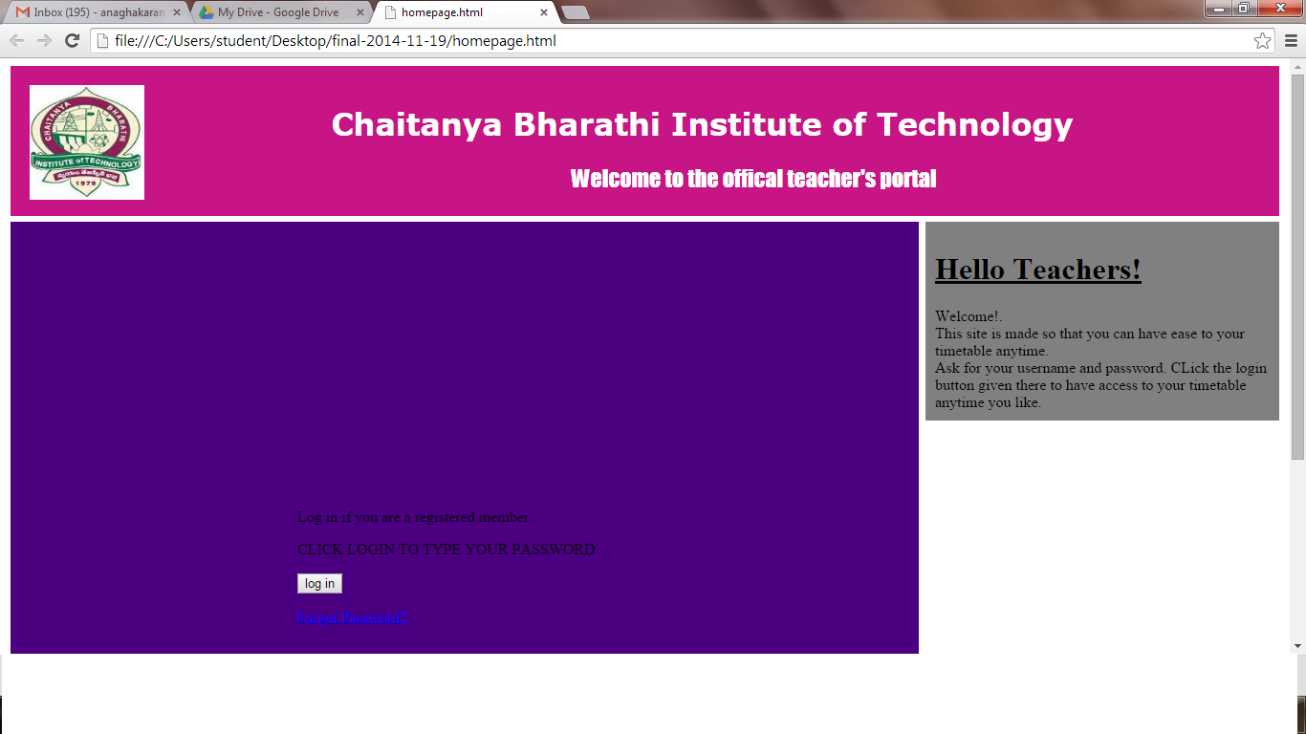

**Fig 4.1 Output screen of Homepage**

**-**10-

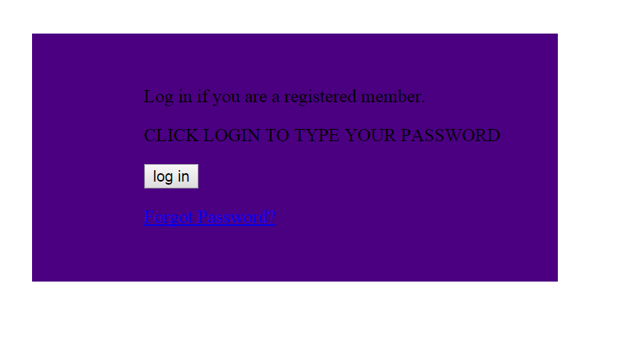

**Fig 4.2 Output screen of Homepage 2**

**-**11-

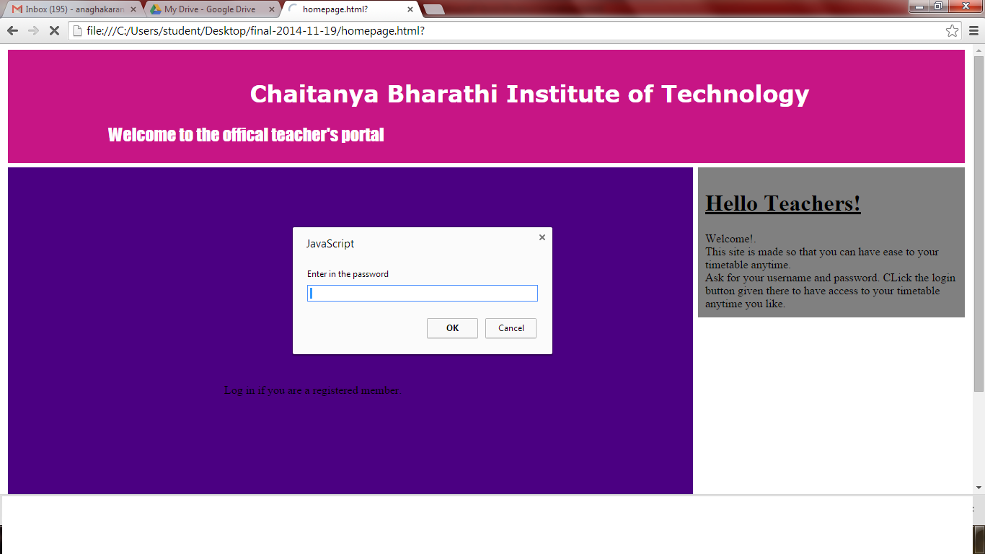

**Fig 4.3 Output screen of Homepage with login**

-12-

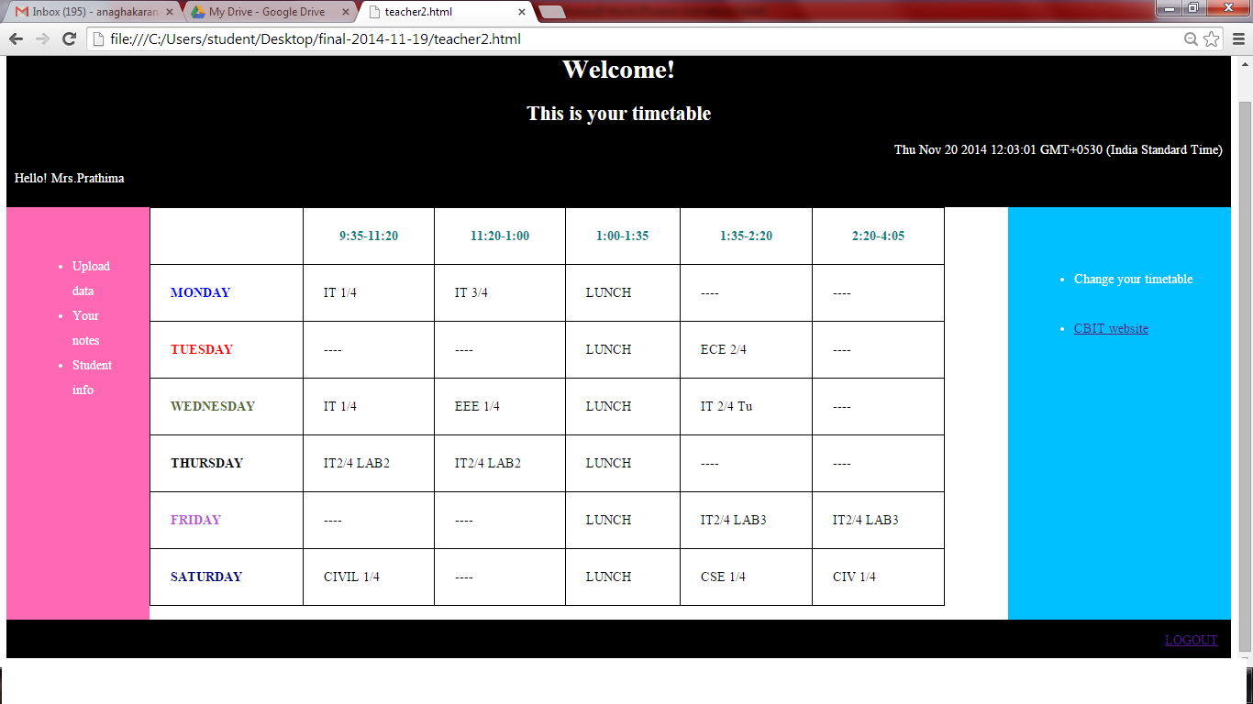

**Fig 4.4 Output screen after login**

-13-

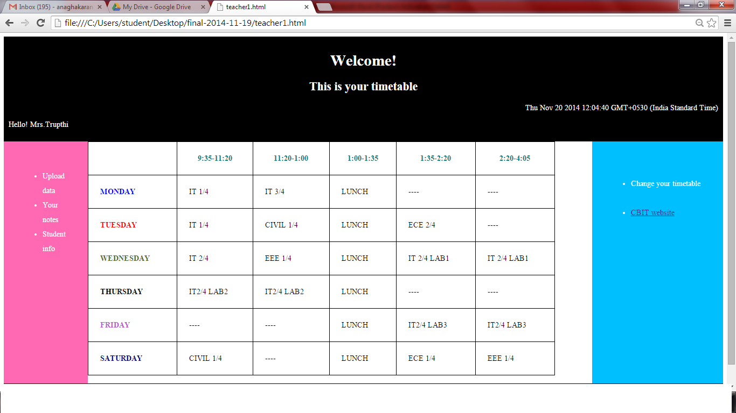

**Fig 4.5 Output screen after login to another account**

-14-

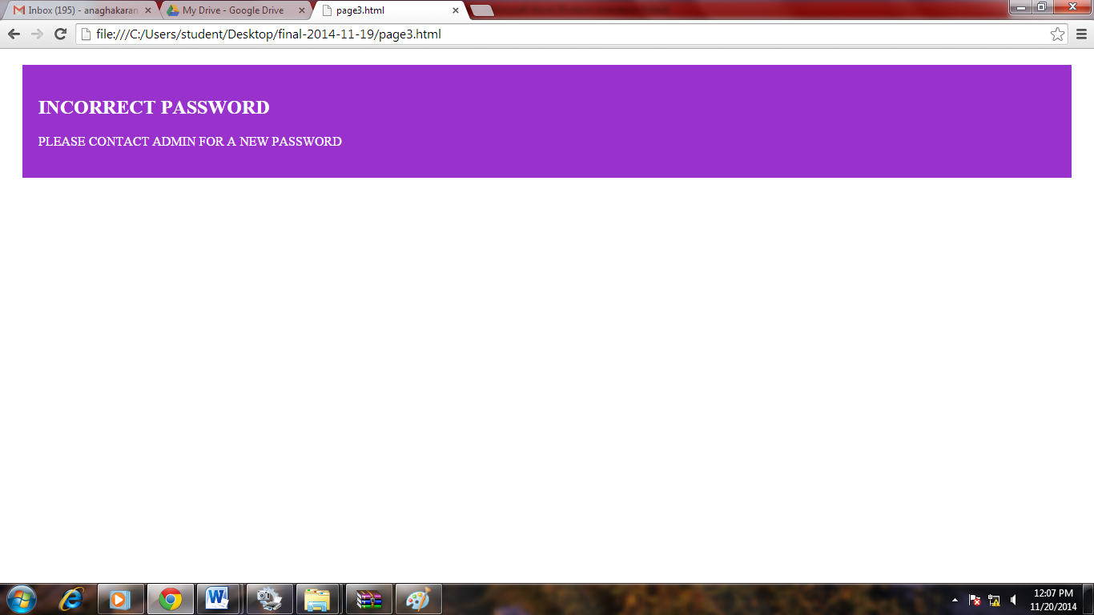

**Fig 4.6 Output screen on incorrect password**

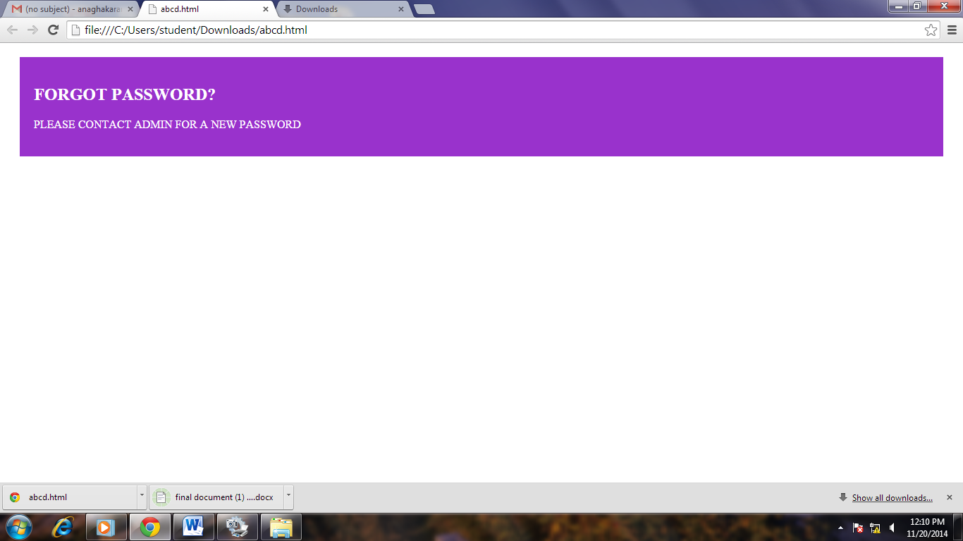 **. Fig 4.7 Output screen if forgot password**

-15-

**5. CONCLUSION AND FUTURE SCOPE**

Even though we are able to provide the basic solution to minimize the problem of teachers, it is not much effective in the real world which is so sophisticated. Since at present only few teachers who are already given an account are able to login, and in case they forget password, they have to contact the admin. But these can be resolved with future enhancements.

**FUTURE SCOPE:**

* Being able to register and make your account and update it when required.
* Change your timetable, upload notes and access to student information.
* Get in touch with other teachers through this portal.

-16-

**BIBLIOGRAPHY**

1. HTML in W3schools.com

2. <www.wikipedia.org>

3. <www.Tutorialspoint.com>

4. <www.cppforschool.com>

-17-